Charts - Questions

Key Stage 2: 2008 Paper B

1.

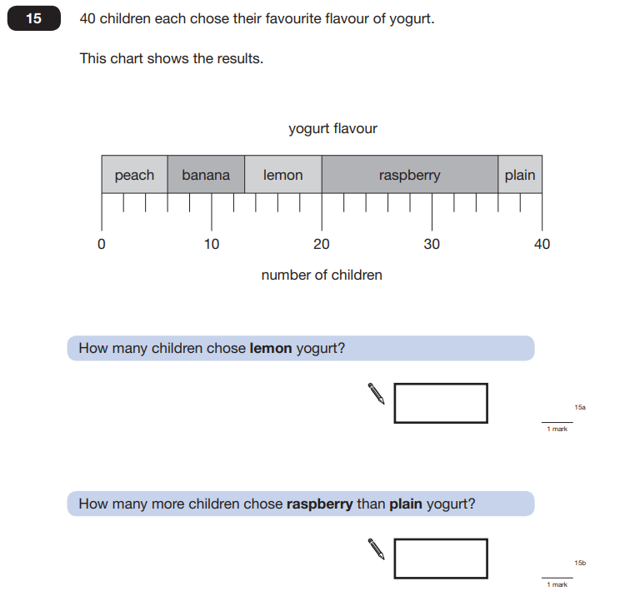

Key Stage 2: 2008 Paper B

2.

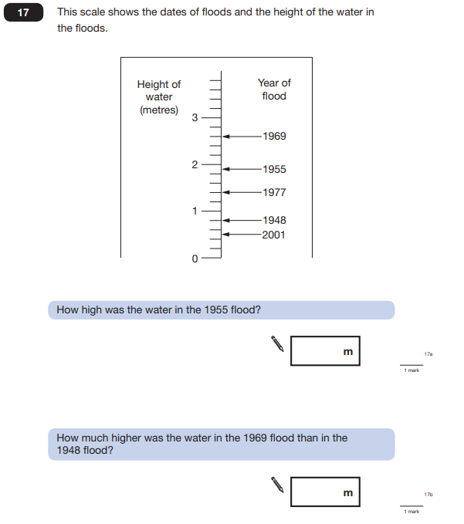

Key Stage 2: 2013 Paper A

1.

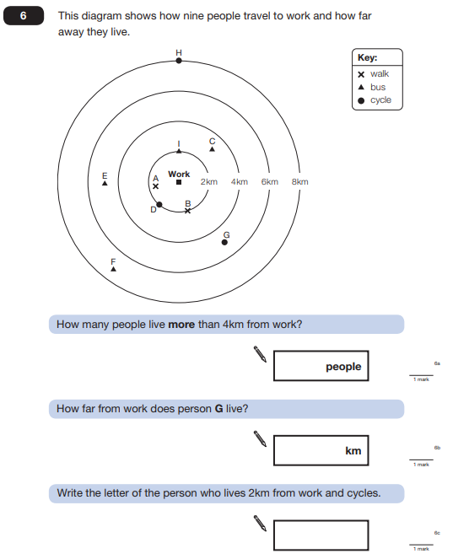

Key Stage 2: 2015 Paper B

1.

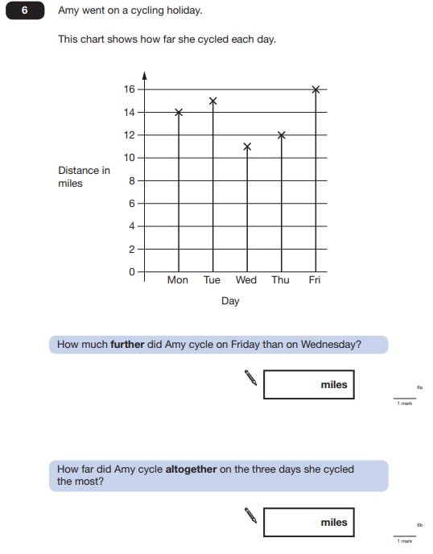

Key Stage 2: 2015 Paper B

2.

