2D SHAPES

KS1 – 2001 Paper

1.

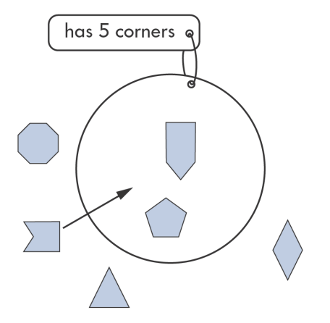

KS1 – 2003 Paper 1

2.

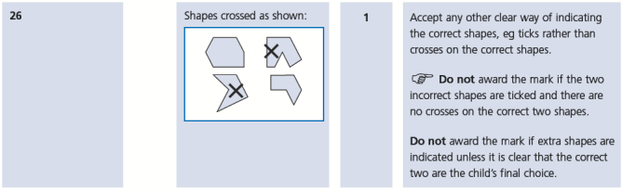

KS1 – 2003 Paper 2

3.

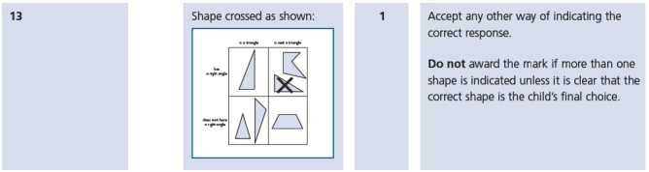

4.

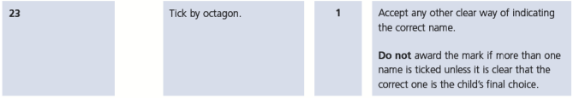

KS1 – 2004 Paper 1

5.

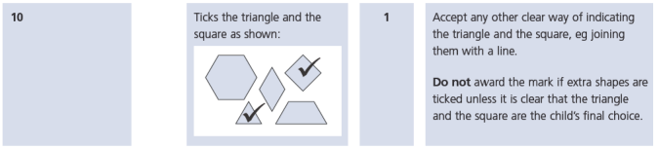

6.

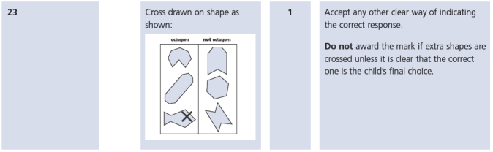

KS1 – 2004 Paper 2

7.

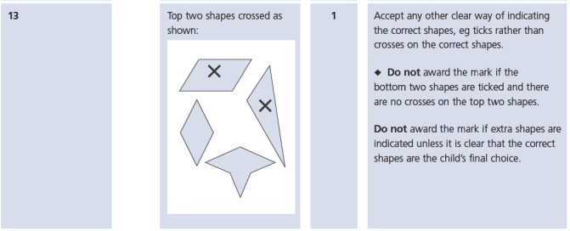

KS1 – 2005 Paper 2

8.

2

KS1 – 2016 Paper - Reasoning

9.

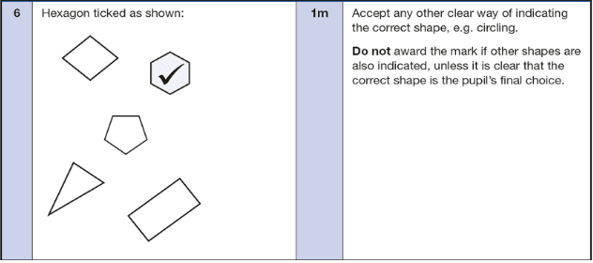

KS1 – 2016 Paper – Reasoning (Second)

10.

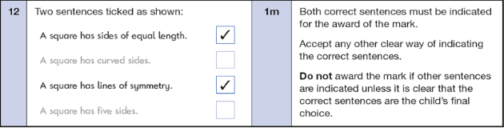

11.

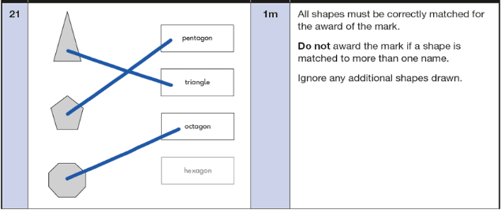

KS1 – 2017 Paper – Reasoning

12.

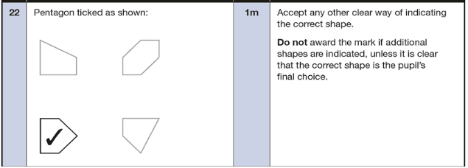

KS1 – 2018 Paper – Reasoning

13.

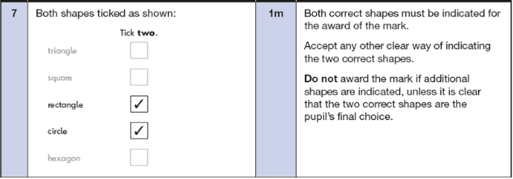

KS1 – 2019 Paper – Reasoning

14.

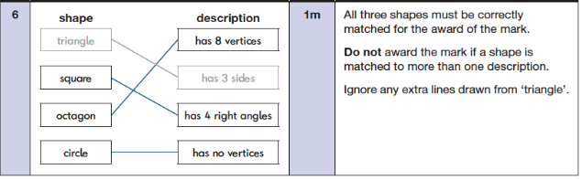

KS1 – 2022 Paper – Reasoning

15.

