CHARTS

KS1 – 2003 Paper 1

1.



KS1 – 2004 Paper 1

2.



3.

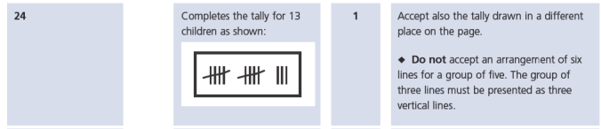

KS1 – 2005 Paper 1

4.

2

5.

Carl, Amy

6.

a. 80 cm

b. 40 cm

KS1 – 2005 Paper 2

7.

8

KS1 – 2007 Paper 2

8.

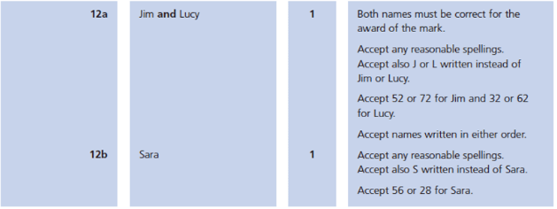

KS1 – 2016 Paper – Reasoning (Second)

9.

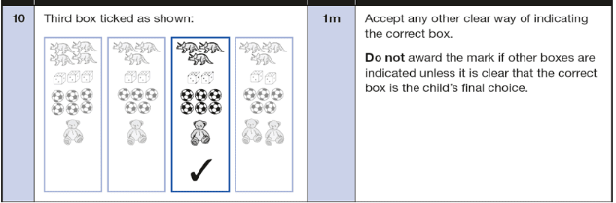

KS1 – 2017 Paper – Reasoning

10.

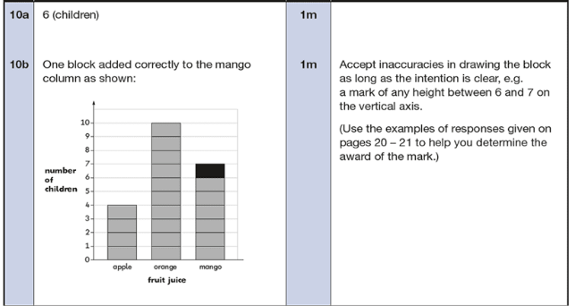

KS1 – 2018 Paper – Reasoning

11.



KS1 – 2019 Paper – Reasoning

12.

